Nargol Ghaziantafrishi

Supervisor: Dr. Christopher Lortie

**Micro to macroclimatic scaling effects on foundation plant species interaction with vertebrate protégé species.**

**Proposal**

The Stress Gradient Hypothesis (SGH) proposes a switch from competition to facilitation with increasingly stressful environmental conditions1. This hypothesis sparked the interest of many2,3 for examining positive interactions. Since, various studies have focused on positive interactions in harsh environments, including arid ecosystems4–6. Facilitation is a type of positive interaction where one interacting species benefits whilst none are harmed7. Thus, positive interactions are studied relatively well when discussing stress; however, many do not measure and report stress effectively. Climate in particular is a stressor typically not explored, nor reported. Thus, to ideally advance the relative importance in stress with global change, we need to measure interactions and climate at different scales, which can includes micro (on site), meso (multiple sites in one location), and macro (multiple locations).

Foundational plant species or nurse plants are an integral part of facilitation research8. These include shrubs that benefit protégé species9 through various mechanistic pathways that include, but are not limited to, seed trapping, abiotic stress amelioration, and soil modification8. There is also capacity for the same interaction pathways to benefit animals in deserts10. An important agent of abiotic stress amelioration is shrub canopy, able to facilitate animals through direct and indirect shelter and refuge effects11,12. This is important because deserts are home to many rare, endemic species of animals and biodiversity is high in drylands. These systems are under threat and many federally listed endangered species are in deserts, including some of the first ever to be listed in the USA13. Hence, it’s crucial to study the diversity of such threatened ecosystems.

Desertification and arid region expansion is a critical global change issue14. The well-being and function of foundation plants species may depend on factors such as in temperature, variability in precipitation, extended drought periods, and radiation15–17. The changes in the above microclimatic parameters are primarily due to anthropogenic climate change18 that significantly modifies physical and biological systems in all continents19. Over the upcoming decades, global desertification will generally continue to increase20. Climate-driven behavioural plasticity encourages shifts in habitat so behavioural regimes can continue to function21. Thus, closing this research gap by examining behavioural-ecological domains such as movement and spatial pattern, forging and vigilance, social organization, and reproductive behaviour22 is important. Plants and animals in deserts will not only experience large scale changes such as droughts, but also small scale changes such fluctuations in temperature and light, since for these organisms deserts are extremely heterogeneous at fine scales23,24. Due to this, it’s important to have data at both levels. Climate envelope models are common tools for species to understand how they respond to change and environmental drivers, though one cannot ignore the interactions that buffer their tolerances, as well25.

What I’m most curious about and propose to do in this project is explore how temperature and light influence the association of vertebrates with shrubs. In addition, I want to re-construct my UV permeable shelters at a grand scale that mimic shrub canopy, which can be used for conservation purposes as new shrubs are grown.

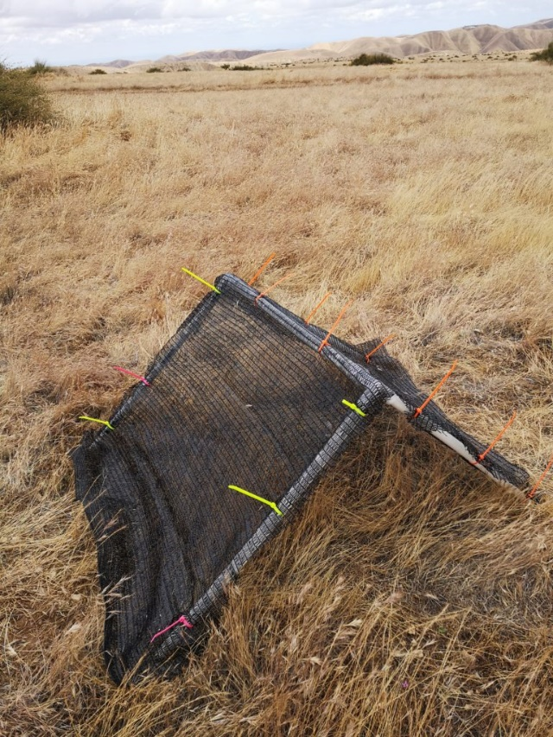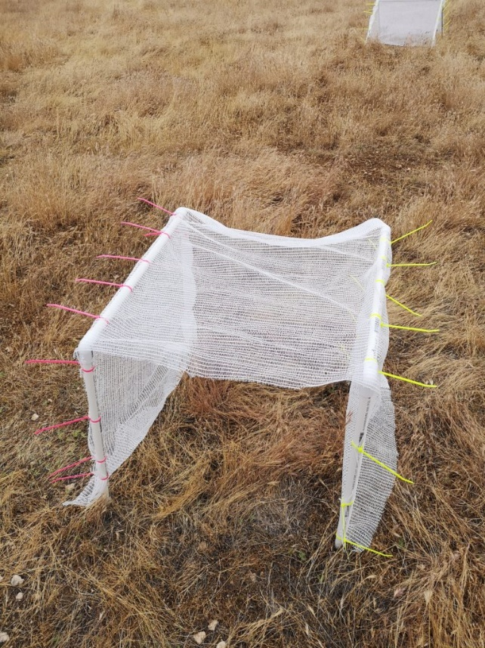

**Figure 1**. An example model of the shelters to be built. Left: square shelter with 15% light blockage. Right: triangle shelter with 50% light blockage.

**Budget**

I’d like to re-construct my UV permeable shelters at a grand scale and pair it with camera trapping and temperature/light loggers. To re-construct these shelters, I would need three different percentages of shades, which I already have from last year’s construction. Camera traps and temperature/light loggers from previous field seasons can also be used. Hence the things that need to be purchased are the PVC pipes, the connecters, zip ties and the stakes to secure the shelters to the ground. Field vehicle and lodging can be covered through my supervisor’s grant. Below is a cost breakdown of the shelter parts:

|  |  |  |  |  |
| --- | --- | --- | --- | --- |
| Part | Approximate cost per unit (USD) | Number of units needed per shelter | X 30 | Total |
| 61cm ½ inch pipe | 1.20 | Square: 8  Triangle: 4 | 240  120 | 288  144 |
| 90° elbow | 1.50 | 4 | 120 | 180 |
| Adapter ½ to ¾ | 0.9 | 2 | 60 | 54 |
| 61cm ¾ inch pipe | 2.00 | 1 | 30 | 60 |
| 3 way 90° elbow | 1.60 | 2 | 60 | 96 |
| Zip ties | 12.00 | 2 |  | 24.00 |
| Metal stakes | 2.75 | Square: 8  Triangle: 4 | 240  120 | 660  330  **$1,836** |

The total to execute this project amounts to $1,836. If I were to be awarded the $1000, executing this project would be made much easier as my supervisor would only have to cover about $800 worth of shelter equipment. This cuts back quite a bit of the cost of turning this grand-scale project into reality.

**Literature Cited**

1. Bertness, M. D. & Callaway, R. Positive interactions in communities. *Trends Ecol. Evol.* **9**, 191–193 (1994).

2. McIntire, E. J. B. & Fajardo, A. Facilitation as a ubiquitous driver of biodiversity. *New Phytol.* **201**, 403–416 (2014).

3. Fajardo, A. & McIntire, E. J. B. Under strong niche overlap conspecifics do not compete but help each other to survive: facilitation at the intraspecific level: Intraspecific facilitation in Nothofagus pumilio. *J. Ecol.* no-no (2010). doi:10.1111/j.1365-2745.2010.01771.x

4. Maestre, F. T., Callaway, R. M., Valladares, F. & Lortie, C. J. Refining the stress-gradient hypothesis for competition and facilitation in plant communities. *J. Ecol.* **97**, 199–205 (2009).

5. Michalet, R., Le Bagousse-Pinguet, Y., Maalouf, J.-P. & Lortie, C. J. Two alternatives to the stress-gradient hypothesis at the edge of life: the collapse of facilitation and the switch from facilitation to competition. *J. Veg. Sci.* **25**, 609–613 (2014).

6. Lu, R. *et al.* Nurse effects of patch-canopy microhabitats promote herbs community establishment in sandy land. *Ecol. Eng.* **118**, 126–133 (2018).

7. Bertness, M. D. & Leonard, G. H. THE ROLE OF POSITIVE INTERACTIONS IN COMMUNITIES: LESSONS FROM INTERTIDAL HABITATS. *Ecology* **78**, 1976–1989 (1997).

8. Filazzola, A. & Lortie, C. J. A systematic review and conceptual framework for the mechanistic pathways of nurse plants: A systematic review of nurse-plant mechanisms. *Glob. Ecol. Biogeogr.* **23**, 1335–1345 (2014).

9. Gómez-Aparicio, L. *et al.* APPLYING PLANT FACILITATION TO FOREST RESTORATION: A META-ANALYSIS OF THE USE OF SHRUBS AS NURSE PLANTS. *Ecol. Appl.* **14**, 1128–1138 (2004).

10. Lortie, C. J., Filazzola, A. & Sotomayor, D. A. Functional assessment of animal interactions with shrub-facilitation complexes: a formal synthesis and conceptual framework. *Funct. Ecol.* **30**, 41–51 (2016).

11. Lortie, C. J., Gruber, E., Filazzola, A., Noble, T. & Westphal, M. The Groot Effect: Plant facilitation and desert shrub regrowth following extensive damage. *Ecol. Evol.* **8**, 706–715 (2018).

12. Bråthen, K. A. & Lortie, C. A portfolio effect of shrub canopy height on species richness in both stressful and competitive environments. *Funct. Ecol.* **30**, 60–69 (2016).

13. Tazik, D. J. & Martin, C. O. Threatened and Endangered Species on U.S. Department of Defense Lands in the Arid West, USA. *Arid Land Res. Manag.* **16**, 259–276 (2002).

14. Asner, G. P. & Heidebrecht, K. B. Desertification alters regional ecosystem-climate interactions. *Glob. Change Biol.* **11**, 182–194 (2005).

15. Kogan, F. & Guo, W. 2006–2015 mega-drought in the western USA and its monitoring from space data. *Geomat. Nat. Hazards Risk* **6**, 651–668 (2015).

16. MacDonald, G. M. Severe and sustained drought in southern California and the West: Present conditions and insights from the past on causes and impacts. *Quat. Int.* **173**–**174**, 87–100 (2007).

17. Tattini, M. *et al.* Morpho-anatomical, physiological and biochemical adjustments in response to root zone salinity stress and high solar radiation in two Mediterranean evergreen shrubs, Myrtus communis and Pistacia lentiscus. *New Phytol.* **170**, 779–794 (2006).

18. Gibelin, A.-L. & Déqué, M. Anthropogenic climate change over the Mediterranean region simulated by a global variable resolution model. *Clim. Dyn.* **20**, 327–339 (2003).

19. Rosenzweig, C. *et al.* Attributing physical and biological impacts to anthropogenic climate change. *Nature* **453**, 353 (2008).

20. Reynolds, J. F. *et al.* Global Desertification: Building a Science for Dryland Development. *Science* **316**, 847–851 (2007).

21. Noonan, M. J. *et al.* In situ behavioral plasticity as compensation for weather variability: implications for future climate change. *Clim. Change* **149**, 457–471 (2018).

22. Berger-Tal, O. *et al.* Integrating animal behavior and conservation biology: a conceptual framework. *Behav. Ecol.* **22**, 236–239 (2011).

23. Titus, J. H., Nowak, R. S. & Smith, S. D. Soil resource heterogeneity in the Mojave Desert. *J. Arid Environ.* **52**, 269–292 (2002).

24. Pianka, E. R. Convexity, Desert Lizards, and Spatial Heterogeneity. *Ecology* **47**, 1055–1059 (1966).

25. Kearney, M., Shine, R. & Porter, W. P. The potential for behavioral thermoregulation to buffer ‘cold-blooded’ animals against climate warming. *Proc. Natl. Acad. Sci.* **106**, 3835–3840 (2009).